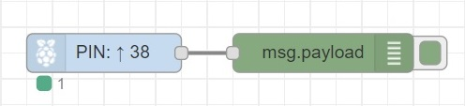

|  |
| --- |
| [{"id":"1491dec6.f2a991","type":"debug","z":"db7e83cf.f4abc","name":"","active":true,"tosidebar":true,"console":false,"tostatus":false,"complete":"payload","targetType":"msg","x":410,"y":140,"wires":[]},{"id":"2843a8b0.19b0c8","type":"rpi-gpio in","z":"db7e83cf.f4abc","name":"","pin":"38","intype":"up","debounce":"25","read":false,"x":240,"y":140,"wires":[["1491dec6.f2a991"]]}] |

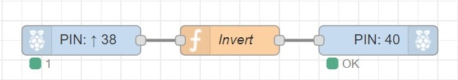

|  |
| --- |
| [{"id":"34fc4bf0.ae7c94","type":"rpi-gpio out","z":"712d83a1.c7c0ac","name":"","pin":"40","set":"","level":"0","freq":"","out":"out","x":500,"y":180,"wires":[]},{"id":"52e5d42c.8caeac","type":"rpi-gpio in","z":"712d83a1.c7c0ac","name":"","pin":"38","intype":"up","debounce":"25","read":false,"x":200,"y":180,"wires":[["dbb8577b.683ee8"]]},{"id":"dbb8577b.683ee8","type":"function","z":"712d83a1.c7c0ac","name":"Invert","func":"if(msg.payload === 1){\n msg.payload = 0;\n return msg;\n}\n\nelse if(msg.payload === 0){\n msg.payload = 1;\n return msg;\n}","outputs":1,"noerr":0,"x":350,"y":180,"wires":[["34fc4bf0.ae7c94"]]}] |